SkillsUSA 2023 Additive Manufacturing State Challenge

Solving real world problems

Welcome to the “Solving real world problems” challenge!

The task at hand is to improve a process outside your home that can be improved using a tool that is printed or made using 3D printing.

Here are some ideas to start you thinking:
- a tool for improving a storage process
- a guide to help with repetitive tasks
- a tool for improving the accuracy of a process
- a visual indicator to reduce time or risk of error
- a problem that affects multiple people

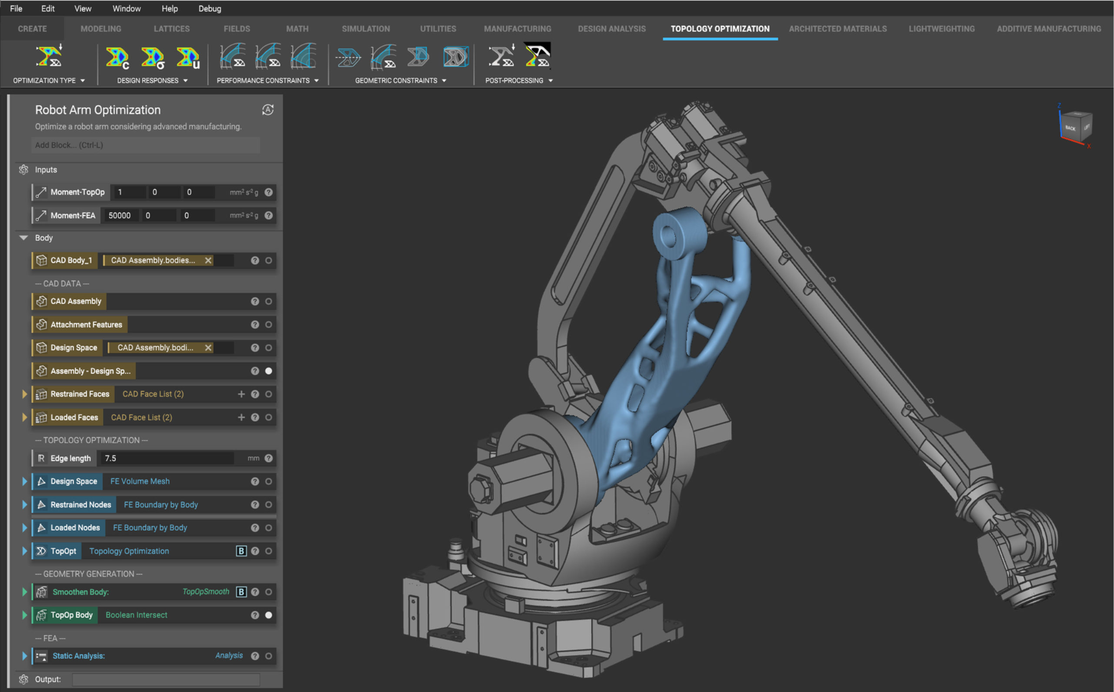
Design for Additive Manufacturing workflows in nTopology

Below are some additional requirements that the problem and solution must satisfy.

Competition Requirements

- The solution you provide is recommended to have real, measurable results (increase in productivity, reduction in user fatigue, time/money savings, reduction in lead time, etc). Theoretical or guessed improvement metrics will not be graded as highly as experimental, proven measurements.

- The design must contain (and communicate) thoughtful decisions around additive versus traditional/off-the-shelf components. At a minimum, it must contain at least one non-3D printed (“traditionally manufactured”) component OR two different materials or colors in the final assembly

- 3D Printed Design - Students must create a design that:
  - Prints all parts in less than 24 hours
  - Uses less than 10 cubic inches of model and support combined for all parts

- Students will bring their printed parts to their presentation time on March 23rd at Utah Valley University in CS 704.

Tips for Competitors
Here are some tips to maximize your points:
- Get creative and gutsy in finding a problem
- Travel to a local manufacturer to uncover pain points
- Use online resources (nTopology, YouTube, GrabCAD)
- Whenever intellectual property (IP) deters you from a project, try using approximate geometries to communicate the design intent
- Consider using 3D printing as a tool to create the tool (thermoforming, epoxy molding, drill guiding, etc.)
- Solve a problem that impacts multiple people
- Incorporate non-3D printed components in your final assembly
- Optional design for additive manufacturing learning resources:
- Stratasys Think Additively™ Masterclass:
  - https://youtube.com/playlist?list=PLUYaY5EIPtNBdU-s-7l9rl05lBHHlTarI
- nTopology Learning Center:
  - learn.ntopology.com

State Competition Procedure
Before or on contest day:
- Students submit Engineering Notebook. If an electronic version is going to be submitted, send it to JeffreyJ@uvu.edu by Wednesday, March 22nd at 11:59 PM. (Engineering notebook guidelines below)
- Students submit their design files (Solidworks, Inventor, Fusion360, etc) to JeffreyJ@uvu.edu by March 22nd at 11:59 PM.
- Students submit physical parts (to be shown during your presentation)
- Students submit final assembly if applicable (can be submitted as a part of your Design Journal)
- Students submit their Presentation to JeffreyJ@uvu.edu by March 22nd at 11:59 PM.

State Competition Judging Criteria

- The Engineering Notebook should contain robust content, including at a minimum the following:
  - Be clearly labeled with contestant name(s), date and page # on each page
  - Begin with a problem statement
  - Include discovery and documentation of approach to solve problem
  - Include sketched design concepts with critical features labeled
  - Critical dimensions clearly labeled in design sketch
  - Considerations for designing for additive manufacturing distinctly addressed (i.e. part strength, part orientation) especially including any expected risks during printing
  - Screenshots of the print time and material usage for all printed parts
  - Design decisions and alternatives are documented and evaluated thoughtfully

- The design must adhere to the Competition Requirements stated in the prior page.

- Quality of final assembly
  - Does it perform the function in the manner it was designed to do?
  - Does it meet all requirements in contest guidelines?
  - Do inserted components or multiple printed parts mate together properly?
  - Did the students design the part with additive manufacturing in mind?

- The design must illustrate best practices for “design for additive manufacturing (DFAM)”. You must explain your selection and use of software for DFAM. It is highly suggested to use a free student license of nTopology (https://ntopology.education/academic_license) to assist you in performing design for additive manufacturing, and to help with explaining the “before and after” effects of DFAM practices. Below are some potential DFAM metrics to optimize for.
  - Build Time
  - Post-Processing Time
  - Functionality Optimization (better grip, pliability, strength, etc.)
  - Monetary Savings
  - Material Consumption
  - Energy Usage
  - Component Consolidation
  - Lightweighting for Ergonomics

- Presentation Criteria
  - The team clearly describes their understanding of the problem to be solved.
  - Design Process: good design logic is used for key design choices. Intentional and well-communicated
  - The presentation is professional and well-rehearsed
  - The presentation emphasizes quantitative improvements (measured and estimated) of the time, quality, or cost of the improvement as well as any DFAM tactics employed.
  - Practical evaluation: team demonstrates visually (videos, photos, drawings, animation, etc) the task they improved, both before and after.

