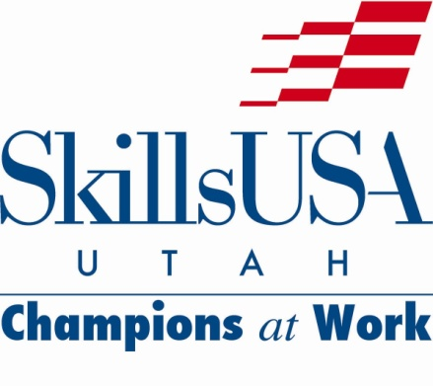

State Director message 10/4/21

SkillsUSA Utah Fall Leadership Conference update:
I am looking forward to a wonderful SkillsUSA Utah Fall Leadership Conference on Tuesday October 12th at Utah Valley University. There are over 300 participants registered for the event. The student officer team and their advisors have prepared great breakout sessions for the students. Our opening general session keynote speaker will be Utah State Senator Daniel Thatcher, a long-time advocate for career and technical education and SkillsUSA Utah.

The registration system is closed, and the conference materials and food have been ordered. Due to construction in the UVU Student Center, I had to move the general sessions and the breakout rooms to the Classroom (Clarke) Building on the main UVU campus. Please check the state website on Tuesday for updated FLC information, an agenda, and maps. Registered advisors, expect a survey in your email. I would like your feedback and questions so I can discuss relevant information during the advisor breakout session.

Friday Flash:
The most recent Friday Flash has been posted to the SkillsUSA Utah website, at utahskillsusa.org. Please read this document because it has the latest valuable information from the SkillsUSA national office, including some new incentive programs.

Register your school as an official SkillsUSA chapter:
I strongly encourage instructors to register their CTE program and/or school as an official SkillsUSA chapter and integrate a full SkillsUSA Program of Work (an annual calendar of leadership development, career development, community service and technical skill assessment activities) into each CTE program curriculum. Please contact the national Customer Care Team for assistance with the chapter registration process. 844-875-4557 or customercare@skillsusa.org.

2022 National Conference site update:
I will be traveling to Atlanta, Georgia this week, along with all members of the State Directors Association, to meet with our national conference hotel people and to review the national conference venues. I will provide a brief report at the fall leadership conference. The live state and national conferences are going to happen!

